COB Workflow – Old vs New
Nov 10, 2026 · @cherry
The new workflow is Chris's workflow updated for trigger 351 only, with more safety checks. It approves only 351 and checks every finalize, but it still erases data on 27/29 claims, may leave them locked, and runs on 5 hardcoded claims. Read from the workflow JSON files only, nothing was run.

Old workflow (Chris's)
File: cob_happy_path_live_v3 (103 nodes). It processed triggers 27, 29 and 351 the same way.
- Keywords: read the Medicare Advantage keyword list from QuickBase. Stop the run if it is empty.
- Claims: fetch_claims reads bot 1280 claims from Oracle. The query takes 20 typed claim IDs, with no trigger filter.
- Loop: take each claim in turn. If a claim fails, unlock it and go to the next.
- Pre-checks, in order. Any yes = transfer, report row, next claim:
  - Claim ID starts with M → WB_MDCR_Default
  - Header trigger 401 → WBC_MDCR_Trigger_401
  - Manually priced → WB_MDCR_Default
  - Dental claim → WBC_MDCR_Dental No Go
  - BRHSPCE → WBC_MDCR_HospiceHol20days
  - Hospice trigger → WB_MDCR_Default
  - No EOB company name → WBC_MDCR_COB
- Keyword match: split the EOB company names and match each to the keyword list. If none match → transfer to WBC_MDCR_COB without locking.
- Lock and read: lock the claim, then read it with ClaimLookup (company names, lines, OI lines, attachments, header triggers).
- Company check, for each company not on the list: no EOB → transfer; payer S or T → transfer.
- Not all matched: partial or none → transfer to WBC_MDCR_COB, then unlock.
- All matched: erase the OI lines and delete the EOB attachments.
- Approve: build approvals for 27, 29 and 351 on the lines and header. If any header trigger can't be approved → unlock and skip (after the erase).
- Finalize: submit with ClaimReprocessing (forceReprocessing true), unlock, write a "completed" report row.
- Report: write the report to QuickBase as a dry run (nothing saved).

New workflow
File: cob_happy_path_live.workflow (1).json, version 0.2.0 (3,100 lines). Built for trigger 351 only.
- Keywords: same as old.
- Claims: fetch_claims takes 5 typed claim IDs. Its comment says trigger-based selection still has to be restored.
- Loop: same, plus a failed claim is unlocked and gets a "Failed" report row.
- Pre-checks: same 7 checks, same order.
- Keyword match: same. None match → transfer without locking.
- Lock and read: lock and ClaimLookup, then a new check: the claim must have attachments, each with a company name. If not → transfer and unlock.
- Company check: same per-company checks. S or T payer goes to manual review (comment: until story B7).
- Not all matched: same, transfer then unlock.
- All matched: erase the OI lines, then look the claim up again (the erase gives the attachment a new ID). EOB attachment delete is turned off (has_fresh_attachments forced to False).
- Approve: only 351 is approved (code domain ExceptionDomain).
  - A line or header with 27/29 → transfer to WBC_MDCR_COB, report row. No unlock step.
  - Any other header code that can't be approved → unlock and skip.
- Finalize and verify: submit with ClaimReprocessing, then verify_lookup reads the claim back. Final with triggers approved → unlock, "completed" row. Otherwise → unlock, "Failed" row.
- Report: write to QuickBase for real (dry_run false, can be overridden by a setting), build an Excel report and email it (email still a dry run with a placeholder recipient). Failed rows are written separately.

What differs
Of 13 phases, 5 are the same, 5 changed and 3 still have issues.
Phase | Old (Chris's) | New | Result
Keywords | QuickBase list, stop if empty | Same | Same
Claim selection | 20 typed IDs | 5 typed IDs | Issue
Pre-checks | 7 checks | Same order | Same
Keyword match | None match → transfer, no lock | Same | Same
Lock and read | Lock + ClaimLookup | Adds attachment check | Better
Company check | Per-company transfer | Same, S/T to manual review | Issue
Partial / none | Transfer + unlock | Same | Same
Erase OI lines | After all matched | Same, plus re-lookup | Same
Erase EOB | Attachments deleted | Turned off | Changed
Line approval | 27, 29, 351 | 351 only | Better
Header approval | 27, 29, 351 | 351 only; 27/29 transferred | Issue
Finalize | Submit, unlock | Adds verify after submit | Better
Report | QuickBase dry run | QuickBase live + Excel + email | Changed

Issues and limitations in the new version
Three issues block go-live: 27/29 claims are changed before they are skipped, they may stay locked, and the claim list is hardcoded.
# | Priority | Issue | Node(s) | Why it matters
1 | High | 27/29 claims are not skipped at the start. If all names match, they are locked and their OI payments erased, then transferred at the approval step. | fetch_claims, route_header_triggers_approved, route_line_triggers_approvable | Data on descoped claims gets changed
2 | High | No unlock after the 27/29 transfer. Every other transfer after a lock has one. | transfer_triggers_not_resolved, transfer_header_triggers_not_resolved | Claim may stay locked by the bot
3 | High | Claim list is 5 typed claim IDs. | fetch_claims | Can't run on real daily claims
4 | Medium | EOB attachment delete is turned off. Comment: deleting it released a QA2 claim without approval. | has_fresh_attachments | BRD expects OI lines and EOB both erased
5 | Medium | transfer_no_eob runs once per company, so one claim can be transferred more than once. | transfer_no_eob | Duplicate transfers and log notes
6 | Medium | S/T payer goes to manual review; comment says BRD step 6d wants erase and finalize (waiting on B7). | transfer_secondary_payer | Differs from the BRD
7 | Low | Partial-match remark says "All company names not found". | transfer_partial_match, report_row_completed_partial_match | Misleading text for the person who picks it up
8 | Low | Comment says retries raised to 2 (later 3), value is 1. | finalize_claim | Not clear which is intended
9 | Low | 27/29 workbasket marked "ASSUMPTION: WBC_MDCR_COB". | transfer_triggers_not_resolved | Claims could go to the wrong team
10 | Low | Description still says Triggers 27/29/351. | description | Out of date
11 | Low | Email report has a placeholder recipient and is a dry run. | email_daily_report | No email is sent
12 | Low | Open defects D30 (no owner or workbasket check) and D31 (lock success not reliable). | Notes in the file | Bot could pick a claim someone is working

Suggestions to fix
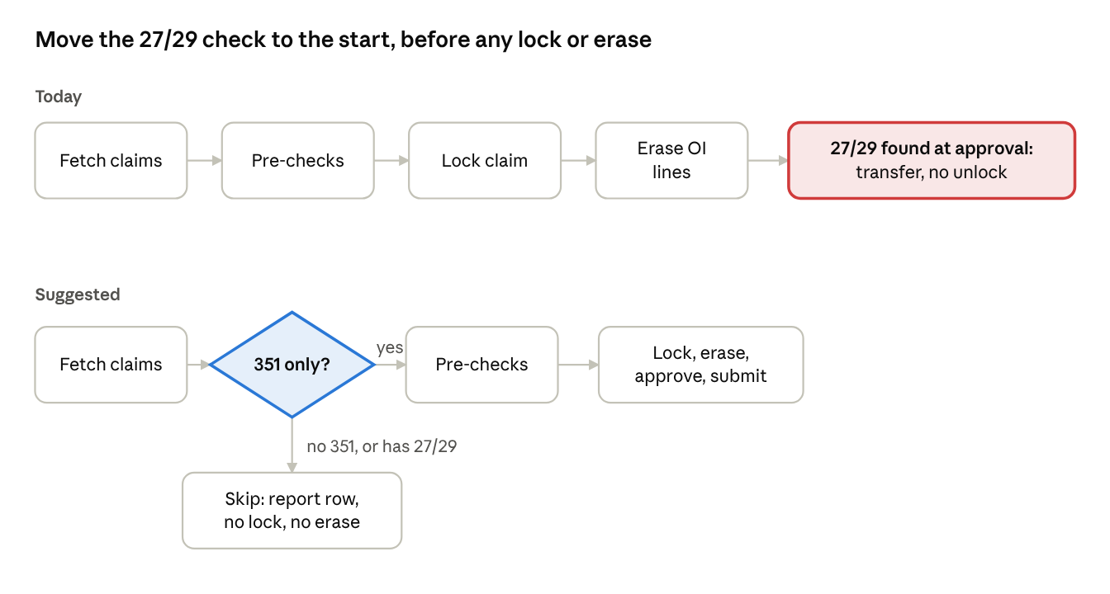
where the 27/29 check sits today vs suggested
Checking for 351 right after fetch_claims means a 27/29 claim is never locked or erased, which also removes the missing-unlock problem for those claims.
# | Issue | Suggestion
1 | 27/29 not skipped at start | Add an if_else right after fetch_claims (or filter in the query) so only 351 claims without 27/29 go on. Business to confirm what to do with a claim that has 351 and 27/29 together.
2 | No unlock after 27/29 transfer | Add an unlock after both transfers, or confirm the transfer releases the lock. Fix 1 makes this path rare.
3 | Hardcoded claim list | Restore the selection query with a 351 filter, then test on agreed QA2 claims.
4 | EOB delete turned off | Confirm with business it is agreed for now; track the HealthEdge release problem as its own story.
5 | Repeated transfers | Transfer once after the company loop, or stop the loop at the first transfer.
6 | S/T payer to manual review | Confirm it is accepted until story B7 is done.
7 | Wrong partial remark | Change to "Some company name(s) not found on keyword list".
8 | Retry comment vs value | Confirm the intended max_attempts and fix the comment or the value.
9 | Assumed workbasket | Confirm WBC_MDCR_COB with business.
10 | Old description | Update to trigger 351 only.
11 | Email not set up | Add real recipients and turn off dry run before go-live.
12 | D30, D31 | Track both as go-live blockers.

